
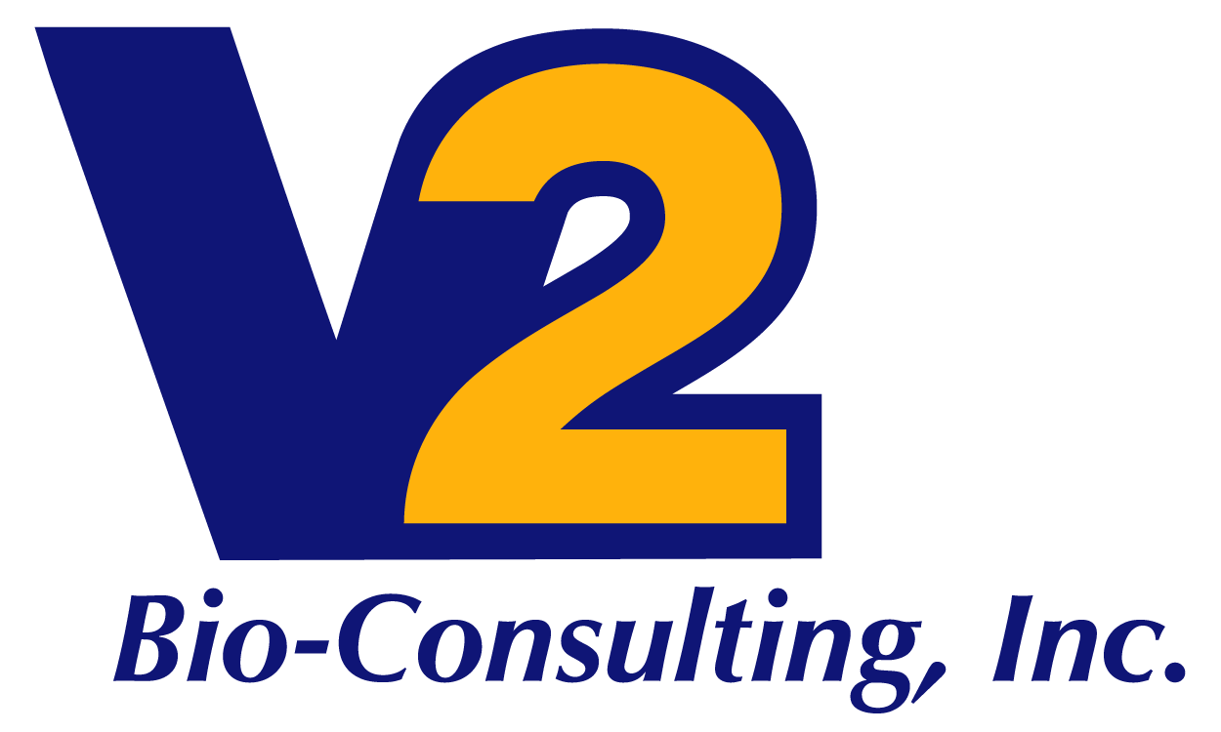

Facility Compliance and Management Services

V2 Bio-Consulting offers 2 levels of services that can include some or all of the following list of Facility Compliance and Management Services. Whether your company already has vendors and needs a Maintenance Management Organization, or your company needs a One-Stop-Shop Program Mangement service to keep you in compliance and in a validated state, V2 Bio-Consulting can be the solution to your needs.

Our Facility Compliance and Management Services include the following:

- Calibration Program Management
  - Procedural guidance
    - Technical writing
    - Training
    - Strict adherence to CFRs, GMPs and industry best practices
  - Process definitions
    - Process mapping and flow charts
  - Vendor scheduling and management
    - Vendor approval process development
    - Manage deliverables and expectations
  - Development of KPIs and metrics
    - Identification of business critical calibration data points
- Preventive Maintenance Programs
  - Procedural guidance
    - Technical writing
    - Training
    - Strict adherence to CFRs, GMPs and industry best practices
  - Process definitions
    - Process mapping and flow charts
  - Vendor scheduling and management
    - Vendor approval process development
    - Manage deliverables and expectations
  - Development of KPIs and metrics
    - Identification of business critical maintenance data points
  - Implement Reliability Centered Maintenance (RCM) practices
- Asset Management
  - CMMS selection, training and implementation
  - Asset identification and management

- HEPA Certification Program Management
  - Procedural guidance
    - Technical writing
    - Training
    - Strict adherence to CFRs, GMPs and industry best practices
  - Process definitions
    - Process mapping and flow charts
  - Vendor scheduling and management
    - Vendor approval process development
    - Manage deliverables and expectations
  - Development of KPIs and metrics
    - Identification of business critical HEPA data points
- Regulatory Readiness
  - Provide regulatory readiness oversight for all site Facilities operations
  - Provide support to agency audits as SME
  - Development of gap mitigation plans and audit responses
- Construction Project Management
  - Factory and site acceptance testing
    - Documentation and asset review
  - Assembly of turnover packages
  - Contractor management and oversight
    - Manage deliverables and expectations
- Site Operation Needs
  - Development business continuity and disaster preparedness plans
  - Energy management
  - Pest control program management
  - Property management interface
  - Management of laboratory and office moves
  - Management of landscape and hardscape needs
  - EH&S program support

