
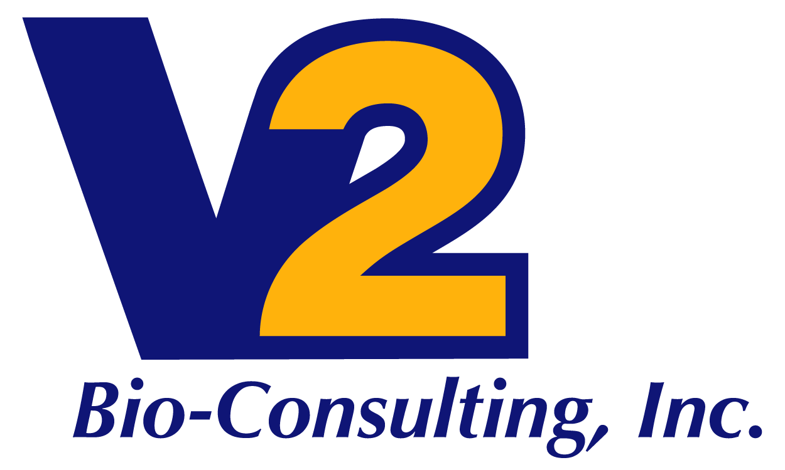

IT Quality Systems Services

V2 Bio-Consulting offers information systems and regulated IT consulting services for the specific needs of BioPharma, BioFuels and Chemicals, and Industrial companies ranging from small start-ups to fully integrated companies with commercial products. From initial planning to go-live and production support, V2 Bio-Consulting has a strong background in all phases of the GMP or GCP information systems project life cycle. Our validated systems experience includes Laboratory Information Management, Document Control, Clinical Trials Management, Quality Management, and Enterprise Resource Planning (ERP). We have knowledge and experience with IT strategy, governance, policy, risk management, automation, and operational processes and procedures in multi-regulatory settings. We offer GMP, GCP as well as Sarbanes-Oxley audit services of IT operations and information systems.

Project Management for automated business systems including qualification and validation:
Full Project Life Cycle with soft/hard gate stages and standardized deliverables: propose > initiate > acquire > plan > design > build > test > deploy > support

We approach projects from the user perspective while attending to IT objectives minimizing resources and on-going cost of support and maintenance. We have strong cross functional business process knowledge and experience designing, implementing and supporting common business systems:
- GCP including Clinical Trials Management, Safety-Adverse Events Reporting
- GMP including Quality Management Systems, Document Control, Lab Information Management, Chromatography Data Systems and Enterprise Resource Planning

IT and Information Systems Audit Services:
- Strategy and project planning for achieving and maintaining FDA and Sarbanes-Oxley compliance
- Staff augmentation for business process subject matter experts and IT professionals to prepare for or conduct audits
- Plan and conduct information systems and data security audits for outsourced clinical data management services as well as contract laboratory and manufacturing vendors
- Assess the effectiveness of IT processes and procedures of your internal or outsourced IT operation, identify deficiencies and gaps, make recommendations and oversee action plans to eliminate or mitigate risks to data security, integrity, availability, and regulatory compliance for FDA and Sarbanes-Oxley
- Liaison with external auditors and help your IT and information systems teams prepare for regulatory audits

