
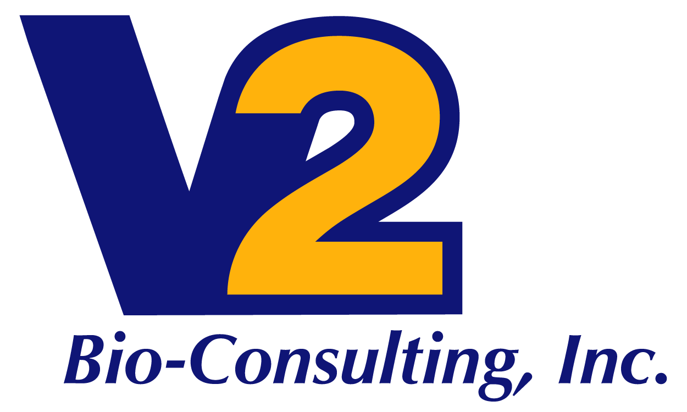

Quality Assurance Services

V2 Bio-Consulting is experienced in the implementation and maintenance of small and large company pharmaceutical quality systems. Our clients look to us for assistance in assessing business partner quality systems and in attaining compliance with external regulations and standards (State, Federal – US and EU) through V2’s development and monitoring of internal policies and procedures. These services are tailored for each client and commonly include the following:

- Develop, oversee, lead and/or support the Quality Assurance function for compliance of investigational supply material, and ultimately commercial supply
  - Develop SOPs and quality manuals
  - Internal/external audits
  - Develop training programs
  - Analyze, organize and staff document control
  - Assess 21 CFR Part 11 compliance
  - Resolve product complaints and investigations
  - Assist in the release of clinical and commercial products
- Provide proactive expert quality advice on pharmaceutical analysis, drug development and manufacturing for in-house or contracted services
  - Oversee and collaborate with contract manufacturing organizations, contract laboratories, and other contract service providers to ensure consistency with corporate goals and development-phase requirements for quality
  - Source, monitor and audit suppliers of material and components
  - Create, negotiate and implement Quality Agreements consistent with FDA and good business practices
  - Methods review and optimization
  - Supplier, CMO and CRO qualification
- Provide assistance to Compliance in the investigation of deviations and out-of-specification results, and advise on corrective actions and final resolution
- Manage, assist in and provide behind-the-scenes support, or serve as liaison, in the event of a regulatory inspection
- Perform risk assessments for critical systems, operations and facilities
- Operations, Quality and CMC document review and Technical Writing
- Provide inspections and mock Pre-Approval Inspections; create, write and submit draft responses to regulatory inspection 483s and Warning Letters
- Provide guidance to assist in the conduct of compliance audits to ensure corrective and preventive actions
- Provide training resources for application of regulations and guidelines to day-to-day operational compliance; provide technical development support as required

