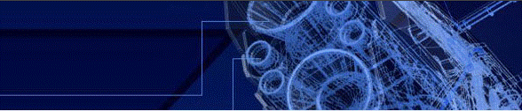
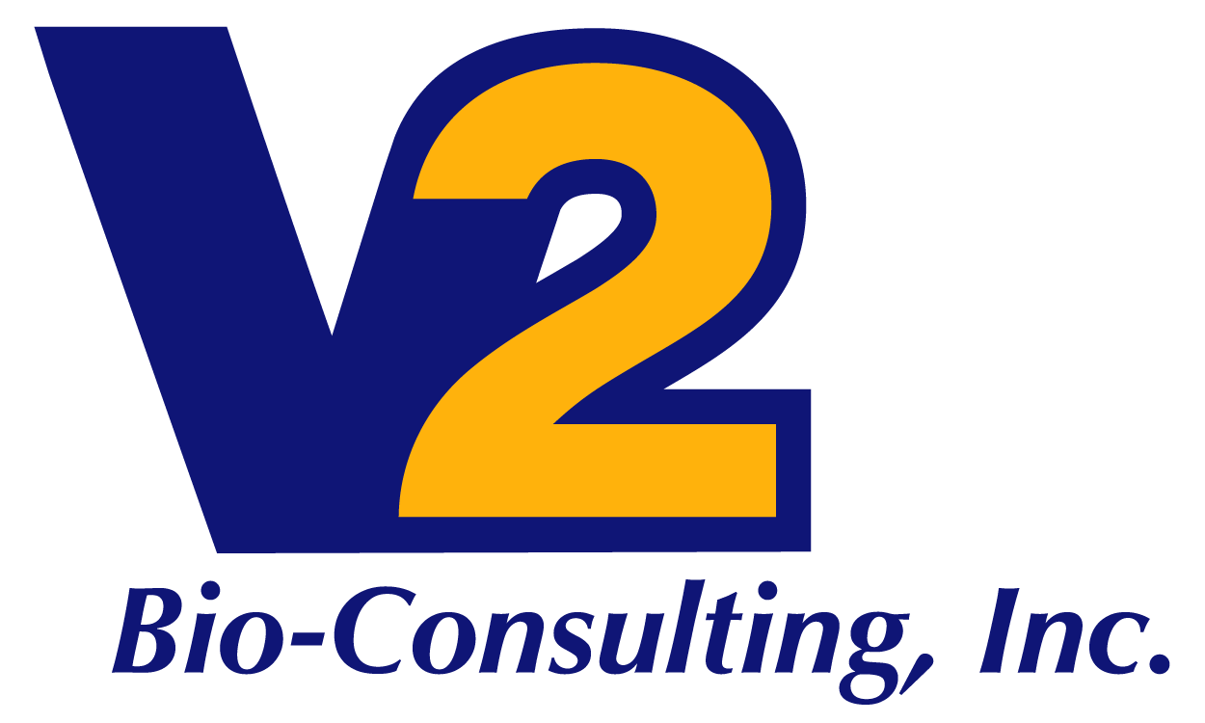

Start-up and Commissioning Management Services

V2 Bio-Consulting provides Start-up and Commissioning Management for execution of projects including major expansions and preparing clients for cGMP operations.
We are a key provider of management associated with construction, start-up, commissioning and validation of your company’s and/or contract facilities. We will manage the Start-up and Commissioning for conformance with client’s internal policies, procedures, partner requirements and external regulations and standards (State, Federal – US and EU).
V2 Start-up and Commissioning Management Services are tailored for each client but can include the following responsibilities:
- Project scheduling
- Validation master plans
- Engineering design review
- Start-up management
- Expert technical personnel
- Complete equipment checkout
  - Mechanical
  - Electrical
  - Instrument
  - Controls
- Detailed commissioning procedures
- Complete equipment turnover documentation
- Detailed technical troubleshooting
- Operating procedure development
- O&M manual development
- Operations supervision and training
- Complete turnkey commissioning projects
- Performance testing

