
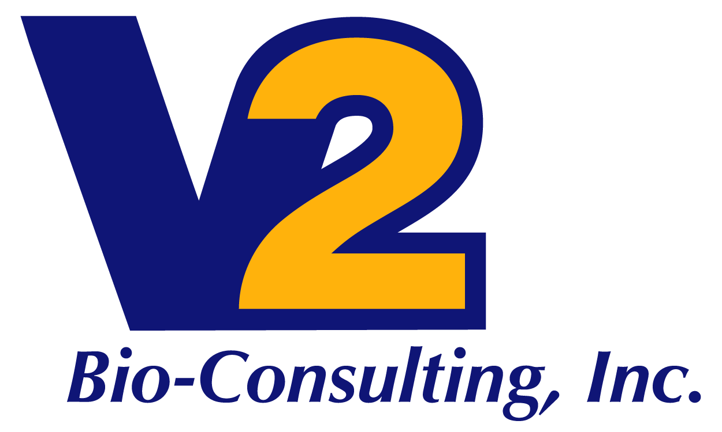

Supply Chain Services

V2 Bio-Consulting provides strategic supply chain management expertise to assist in clinical and cGMP operations.
V2 Supply Chain Services are tailored for each client but can include the following responsibilities:
- Review and recommend updates to establish a robust process for the identification, evaluation, and management of third party contract manufacturers and or providers
- Provide assistance for due diligence visits and assessments
- Review and comment on supply agreements and assist in the negotiation and approval process
- Track and manage supply agreement milestones and deliverables; assist project team meetings and technical operations meetings
- Proactively identify risks and create strategies to avoid or minimize their impact; manage the execution of risk mitigation plans
- Report on CMO performance at manufacturing collaboration operations reviews
- Participate in the Discrepancy Review Board (DRB) and Change Review Board (CRB) as requested
- Support CMO investigations; assist CMO with development and completion of Corrective Actions Preventive Actions (CAPA's) as required
- Participate in Compliance group's audit process from planning through implementation, result evaluation and CMO response review; support inspection readiness activities as required
- Assist with implementation of GMP commissioning activities per approved checklists
- Provide input into the development of CMO-related regulatory submissions

