
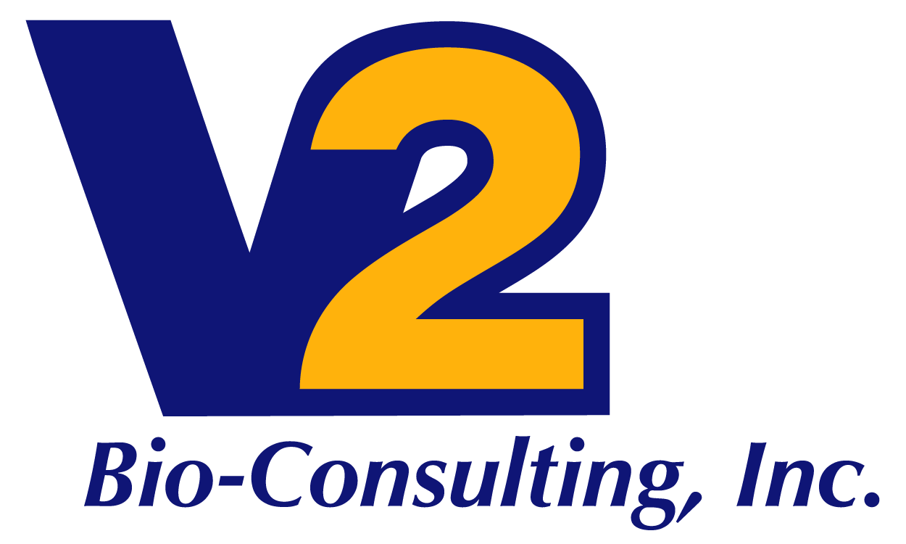

Training Services

V2 Bio-Consulting provides strategic training support for cGMP operations. We provide training associated with operation of your company’s facilities. We can assist with the compliance of internal policies, procedures, partner requirements and external regulations and standards (State, Federal – US and EU).
V2 Training Services are tailored for each client but can include the following responsibilities:
- Provide oversight and assistance as required to deliver training programs that apply to specific clients needs and specific local challenges
- Assistance is likely to be connected to equipment changeovers, production and manufacturing processes, and standard operating procedures
- We generally interact with manufacturing executives as well as other leaders, managers, and individual contributors
- V2 staff will assist to establish the overall strategy for manufacturing site-specific programs and ensures alignment with the other functional areas
- Identify and prioritize site-specific manufacturing training programs for development
- Lead and manage a team of Training Leads within the manufacturing sites who are ultimately responsible for overseeing the development, design, management, maintenance, coordination, and evaluation of site-specific training programs
- Assist in the hire, develop, motivate and provide direction to staff in a way that facilitates the creation of a team environment and enables staff to fulfill the clients operating objectives
- Provide input to build and maintain strong relationships with executives, leaders, managers, and other stakeholders both internally and externally
- Evaluate and reduce redundancy and overlap in content areas
- Raise critical issues and concerns to the governing bodies related to manufacturing site-specific training programs
- Provide clients with learning leadership, being fully aware of the most current learning trends

